Megjegyzés: Az áramkör felépítésének lépései felcserélődhetnek, ez a futás helyességét nem befolyásolja
(ezt bele kell rakni)

Teszt neve | Egyszerű áramkör
Bemenet | loadboard egyszeru.bhdl  setSequence gen01 100111  step  toggleSwitch sw01  step  step
Kimenet | create main (composit)  create gen01 (GENERATOR)  create sw01 (SWITCH)  create w01 (Wire)  create w02 (Wire)  create w03 (Wire)  create main_or1 (Wire)  create led01 (Wire)  egyszeru.bhdl’s Board is loaded.  <main count>  <w01> value is 0  <w02> value is 0  <w03> value is 0  <led01> value is 0  gen01’s sequence is set to 100111.  <main count>  <w01> value is 0  <w02> value is 1  <w03> value is 1  <led01> value is 1  <main step>  <w01> value is 0  <w02> value is 0  <w03> value is 0  <led01> value is 0  sw01’s value changed.  <main count>  <w01> value is 0  <w02> value is 1  <w03> value is 1  <led01> value is 1  <main step>  <w01> value is 0  <w02> value is 1  <w03> value is 1  <led01> value is 1  <main step>  <w01> value is 1  <w02> value is 1  <w03> value is 1  <led01> value is 1
Ábra: | 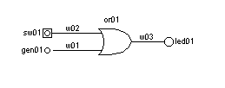

Teszt neve | Visszacsatolt stabil áramkör
Bemenet | loadboard visszacsatolt.bhdl  toggleSwitch sw1  toggleSwitch sw1
Kimenet | create main (composit)  create sw01 (SWITCH)  create w01 (Wire)  create w02 (Wire)  create osc01 (OSCILLISCOPE)  create main_and01 (ANDGate)  visszacsatolt.bhdl’s Board is loaded.  <main count>  <w01> value is 0  <w02> value is 0  <osc01> value is 0  sw01’s value changed.  <main count>  <w01> value is 0  <w02> value is 0  <osc01> value is 0  sw01’s value changed.  <main count>  <w01> value is 0  <w02> value is 0  <osc01> value is 0
Ábra: | 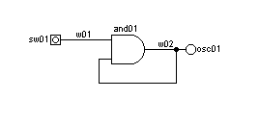

Teszt neve | Instabil áramkör
Bemenet | loadboard instabil.bhdl  toggleSwitch sw1
Kimenet | create main (composit)  create sw01 (SWITCH)  create led01 (LED)  create w01 (Wire)  create w02 (Wire)  create comp01 (composit)  create comp01_w01 (Wire)  create comp01_w02 (Wire)  create comp01_w03 (Wire)  create comp01_w04 (Wire)  create comp01_and01 (ANDGate)  create comp01_inv01 (INVERTER)  instabil.bhdl’s Board is loaded.  <main count>  <w1> value is 0  <comp01 count>  <w2> value is 1  <led1> value is 1  sw1’s value changed.  <main count>  <w1> value is 1  <comp01 count>  x Error: UnstableCircuit
Ábra: | 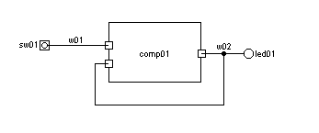  A kompozit belülről:  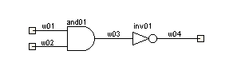

Teszt neve | Bonyolult áramkör
Rövid leírás | A megbeszélés alatti közös feladat letesztelése
Teszt célja | A működés bizonyítása egy bonyolult áramkörön.
Bemenet: | loadboard orai.bhdl  setSequence gen01 0110  toggleSwitch sw01  step
Kimenet: | create w01 (Wire)  create w02 (Wire)  create w03 (Wire)  create w04 (Wire)  create w05 (Wire)  create sw01 (SWITCH)  create x_y_generator (GENERATOR)  create led01 (LED)  create os01 (OSCILLOSCOPE)  create c1 (composit)  create c1_v1 (Wire)  create c1_v2 (Wire)  create c1_v3 (Wire)  create c1_v4 (Wire)  create c1_and1 (ANDGate)  create c1_and2 (ANDGate)  create c1_or1 (ORGate)  create c1_inv1 (INVERTER)  orai.bhdl’s Board is loaded.  <main count>  <w01> value is 0  <w02> value is 0  <w05> value is 1  <comp01 count>  <w03> value is 0  <w04> value is 0  <led01> value is 0  <osc01> value is 0  gen01’s sequence is set to 0110.  <main count>  <w01> value is 0  <w02> value is 0  <w05> value is 1  <comp01 count>  <w03> value is 0  <w04> value is 0  sw1’s value changed.  <main count>  <w01> value is 1  <w02> value is 0  <w05> value is 1  <comp01 count>  <w03> value is 1  <w04> value is 1  <led01> value is 1  <osc01> value is 1  <main step>  <w01> value is 1  <w02> value is 1  <w05> value is 0  <comp01 count>  x Error: UnstableCircuit
Ábra: | 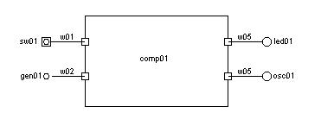  A kompozitbelülről:  